BIOENG320- Synthetic Biology

Solutions to questions from WEEK 01

Q1. Describe the application of engineering the CCR5 receptor to increase and decrease the affinity to its ligands CCL5. Why could both be beneficial?

A1. Engineering the CCR5 receptor offers a versatile strategy for modulating immune responses. By increasing CCR5's affinity to its ligand CCL5, one can enhance chemotaxis, promoting the recruitment and activation of immune cells—such as CAR-T cells—in the tumor microenvironment, which may improve cancer treatment outcomes. Conversely, reducing the receptor's affinity for CCL5 can decrease immune cell infiltration, thereby mitigating inflammation in autoimmune conditions. Moreover, diminished CCR5 signaling may lower the secretion of pro-angiogenic factors, reducing angiogenesis and the subsequent risk of tumor metastasis. Fine-tuning this receptor–ligand interaction through protein engineering thus enables tailored therapeutic approaches to either boost anti-tumor immunity or alleviate pathological inflammation and metastatic progression.

Q2. Propose two mutations to a) increase and b) decrease the affinity or CCR5 to its ligand and explain the logic behind them. For each mutation provide clear pictures of the place where the mutation will be made, show contacts and distance to support your discussion.

A2. The effects of two mutations are given as a representative of the expected information from your answers. Please refer to the table below to check whether your selected mutations match the resulting effect as mentioned in the table. If yes, try to analyse them according to the given example. If No, try to figure out the fault in your interpretation and try to justify what you see in the table.

Mutation to Increase Affinity: T16D
In the wild-type CCR5, threonine at position 16 (T16) is located approximately 5 Å from arginine 47 (R47) on CCL5. By substituting T16 with aspartic acid (D), a negative charge is introduced at this position. This change can facilitate the formation of a salt bridge with the positively charged R47, enhancing the stabilizing electrostatic interaction between CCR5 and CCL5, which in turn is expected to lower the binding energy and increase the receptor’s affinity for its ligand.

Mutation to Decrease Affinity: K26A
Lysine at position 26 (K26) in CCR5 normally forms a strong polar interaction with aspartic acid 5 (D5) on CCL5, with a distance of about 3.8 Å. Replacing K26 with alanine (A) removes the positive charge and the hydrogen bonding capacity of lysine, effectively disrupting the salt bridge with D5. This loss of stabilizing interaction is anticipated to reduce the overall binding affinity between CCR5 and CCL5.
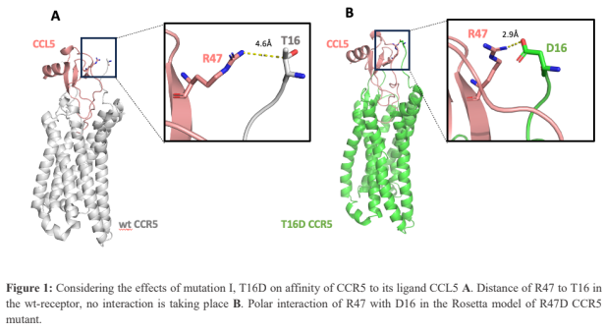

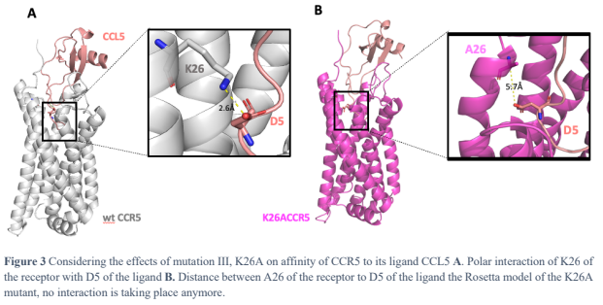

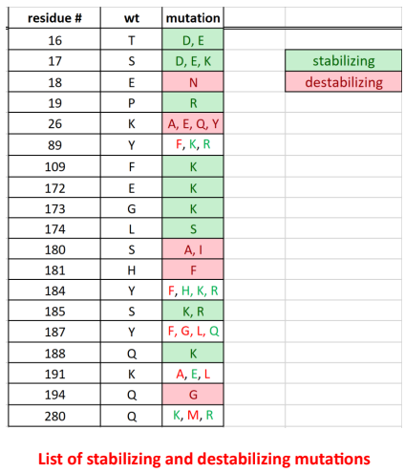

Q3. Would you see an interest in combining all stabilizing or destabilizing mutations into a single variant? What would be the pros and cons of this strategy? Think about the possibility of cumulative effects.

A3. Combining multiple mutations into a single variant can be attractive for achieving more pronounced effects on binding affinity, but it also carries potential risks. Key points include:
- Pros:
  - Additive/Synergistic Effects: Stabilizing mutations (like T16D) may collectively introduce additional salt bridges or hydrogen bonds, further lowering the binding energy and enhancing affinity. Conversely, combining destabilizing mutations (like K26A) might more effectively disrupt multiple key interactions, resulting in a larger reduction in affinity.
  - Fine-Tuning: A combined approach allows for precise modulation of receptor-ligand interactions, which can be beneficial when tailoring the receptor for specific therapeutic applications.
- Cons:
  - Structural Distortions: Individual mutations already introduce measurable deviations (e.g., RMSD increases). Combining them could lead to cumulative structural distortions, potentially affecting receptor folding, stability, or proper surface expression.
  - Non-Linear Effects: The impact of individual mutations might not be simply additive. Epistatic interactions could lead to unexpected non-linear outcomes, where the combined effect deviates from the sum of individual effects.
  - Functionality Trade-Offs: While aiming to modulate binding affinity, the overall receptor functionality could be compromised if the cumulative structural changes interfere with other essential receptor functions

Takeaways from WEEK 02
Given below are a few examples of how the Rosetta generated models for each mutation can be interpreted and compared with the WT structure to conclude the actual effect of the mutation.
For stabilizing mutations:
Rosetta Model for Mutation T16D (RMSD to wtCCR5: 1.542 Å)
The Rosetta model for the T16D mutation in the CCR5–CXCL5 complex shows that substituting threonine with aspartic acid at position 16 results in an additional salt bridge formation with arginine 47 of CXCL5. The carboxyl group of D16 is approximately 3 Å from the guanidinium group of R47, fitting within the optimal salt bridge range of 2.5–4 Å. However, the relatively high RMSD of 1.542 Å compared to the wild-type receptor indicates a significant structural distortion, which could potentially hinder optimal CCL5 binding.
For destabilizing mutations:
Rosetta Model for Mutation K26A (RMSD to wtCCR5: ~1.3 Å)
The K26A mutation was introduced to disrupt the salt bridge between lysine 26 of CCR5 and aspartic acid 5 of CCL5. In the modeled CCR5–CXCL5 complex, this mutation increases the distance between the formerly interacting residues to about 5.7 Å, effectively abolishing the salt bridge. The RMSD, reported in the range of approximately 1.234–1.380 Å relative to the wild-type receptor, suggests moderate structural distortion, likely leading to a decrease in binding affinity without completely eliminating ligand interaction.
Rosetta Model for Mutation K191A (RMSD to wtCCR5: 1.341 Å)
In the K191A mutation, lysine 191 is substituted with alanine, a change intended to disrupt the two hydrogen bonds normally formed by the lysine’s amino group with the backbone carbonyls of K33 and C34. The model confirms that these interactions are lost due to the inability of alanine’s methyl group to act as a hydrogen donor. The increased distances between the alanine residue and the carbonyl groups further support the loss of these stabilizing interactions. The RMSD of 1.341 Å indicates a moderate degree of structural distortion.

